Quimby’s Bookstore
1854 West North Avenue
Chicago IL 60622
773/342-0910
www.quimbys.com


Craig Thompson Celebrates Habibi at Quimby’s 11/17
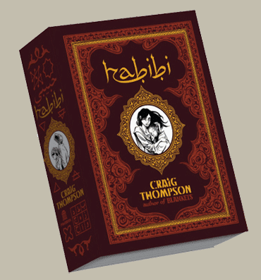
Sprawling across an epic landscape of deserts, harems, and modern industrial clutter, Habibi (Pantheon Books) tells the tale of Dodola and Zam, refugee child slaves bound to each other by chance, circumstance, and love. We follow them as their lives unfold together and apart; as they struggle to make a place for themselves in a world fueled by fear and greed. At once contemporary and timeless, Habibi gives us a love story of astounding resonance; a parable about our relationship to the natural world, the cultural divide between the first and third worlds, the common heritage of Christianity and Islam, and the magic of storytelling.

“HABIBI is a remarkable feat of research, care, and black ink, and a reminder that all "People of the book," despite the division of their individual traditions, share a mosaic of stories.”—Zadie Smith, Harper’s Magazine

“A fantastical love story of a harem girl and the slave boy she rescues, inspired by the Arabian Nights, ancient calligraphy, and modern environmental catastrophe.”—Dan Kois, New York Magazine

Craig Thompson is the award-winning author of the graphic novels Blankets and Good-bye, Chunky Rice.

For more info:
quimbys.com/blog/store-events
pantheonbooks.com
Fo r publicty, contact: Michiko Clark, 212-572-2568, miclark@randomhouse.com

Thurs, Nov 17th, 7pm
Quimby’s Bookstore
1854 W. North Ave. Chicago quimbys.com

